A Guideline for Students for Science Fair Projects
On your presentation day, bring: DISPLAY BOARD, NOTEBOOK, PROPS
A) NOTEBOOK: Your notebook should contain detailed information on your Science Fair project. It should be typed with numbered pages. Appropriate fonts and font sizes should be chosen. You should have your report proofread for possible errors. In addition, it must include each of the following items and in the following order:
Date Due | Done  √ | STEP | DESCRIPTION
 |  | 1. TITLE PAGE | - Your project title, your first and last names, your homeroom teacher's name, and our school’s name
 |  | 2. TABLE OF CONTENTS | - a listing of the items and page numbers of the notebook’s contents
 |  | 3. ABSTRACT | - a summary of your project. Your abstract consists of three short paragraphs. The first paragraph describes your question/problem and why you choose it. The second paragraph describes your methods and materials. The last paragraph presents your results and conclusions. Your entire abstract should fit on one page.
 |  | 4. BACKGROUND RESEARCH | -research on your topic, information used should be referenced properly. Your background research should be at least one paragraph. (see REFERENCES below)
 |  | 5. QUESTION/  PROBLEM | - description of the question which your experiment will attempt to answer (include how it is relevant to a real world problem)
 |  | 6. HYPOTHESIS | - your prediction of the results of your experiment- should be written as a “If…, then… because…” statement.
 |  | 7. MATERIALS | - list all of the materials used using bullets
 |  | 8. PROCEDURE | - a complete, numbered, step-by-step description of each step of your experiment (labeled diagrams may be used)
 |  | 9. RESULTS | - an organized table of your experimental data. Titled graphs and diagrams should be included for quantitative data
 |  | 10. CONCLUSION | - the answer to your question/problem. Include description of the meaning your experimental data. Exactly what does your experiment prove?
 |  | 11. REFERENCES | - gives credit for all reference and research material used.  For:  Web sites: Site name and URL  Books: Title and page number  Encyclopedia: Title, volume number and page number  Periodicals: Name and date of periodical, title and page number of article
 |  | 12. ACKNOW-  LEDGEMENTS | - a thank you note for any assistance that you have received
B) DISPLAY BOARD:
Use a three-sided display board. These are available at most business or education supply stores. Here are some suggestions for creating an effective Science Fair Display Board:
- it should attract attention without being garish.
- the title should be eye-catching and easy to read. Be sure that the letters are large enough to read across a room. The title should be different than your question.
Set up your board in this manner (the question should go on the left side panel just above the hypothesis):
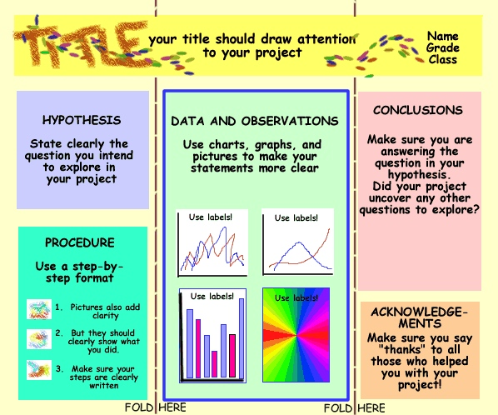

Before you begin, make sure you make a preliminary plan of your board. Boards are expensive and this initial planning may save you some money.
C) PROPS:
Your notebook will be displayed on the table in front of your display board. Any equipment used for your project may be displayed on your table as well in front of your board. You props should fit in the this space.

